# Ability System Tutorial

table of Contents

Ability System Tutorial 1

Class description 1

AbilityBlackBoard: 1

TaskBase: 3

AbilityComponent: 3

Ability: 4

AbilityProcess: 7

EffectTak: 8

Make a Ability 8

1. Ability description: 8

Fire a fireball and reach the target after 2 seconds, apply 50 damage every 0.5 seconds for 3 seconds 8

2. Basic Settings: 8

3. Setting Attribute and EffectSlot: 9

4.BP_Ability: 10

5.Edit PlayMontage_Process: 10

6. LaunchProjectile_EffectTask: 11

7. Fire_EffectTask： 12

## Class description

### AbilityBlackBoard:

This is the data layer of the Ability. You can get this data anywhere, and you can set the data anywhere. You can customize the setting data or use the setting data interface provided by the plug-in.

Note: AbilityBlackBoard template must be set in the project settings



#### 1.Attributes List:

You can set the properties that need to be stored here, and you can manipulate these properties through the interface

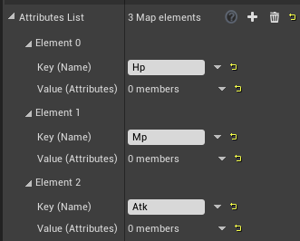

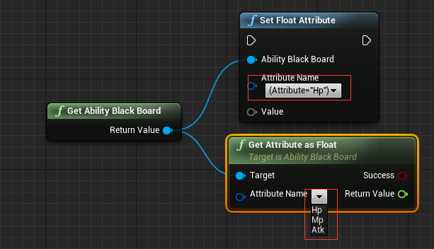

#### 2.Effect Slot List:

You can set the name of the effect here, and start this effect through ActivateEffectTask (provided that you need to design this effect in the detailed panel)

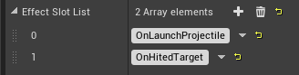

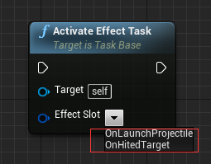

### TaskBase:

Base class for all ability related classes.

Override function:

|  |  |
| --- | --- |
| OnPreActivate | When TaskBase is pre activated |
| OnActivate | When TaskBase is activated |
| OnEnded | When TaskBase ends |
| OnInterrupt | When TaskBase is interrupted. |

### AbilityComponent:

All Actors who need to release their Ability must mount this plugin. Before activating a Ability, a Ability must be registered

Function:

|  |  |
| --- | --- |
| RegisterAbility |  |
| UnRegisterAbility |  |
| RegisterAndActivateAbility |  |

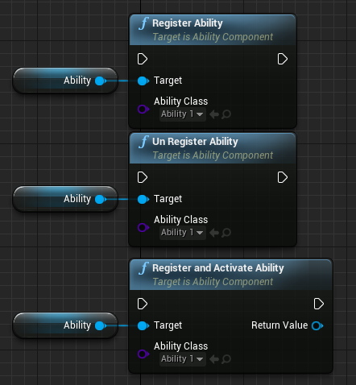

### Ability:

Ability instance, you can quickly design a Ability process in the detailed panel, or you can completely customize a Ability process in the Blueprint.

Override function:

|  |  |
| --- | --- |
| OnPreActivate | When Ability is pre activated |
| OnActivate | When Ability is activated |
| OnEnded | When Ability ends |
| OnInterrupt | When Ability is interrupted. |

#### 1.Auto Activate Ability Sequence:

If true, Ability will execute the AbilityProcess in the detailed panel. When one of the AbilityProcesses fails, or all AbilityProcesses are completed, the Ability will be ended. If false, the Ability will execute the blueprint.

#### 2.Process Sequence:

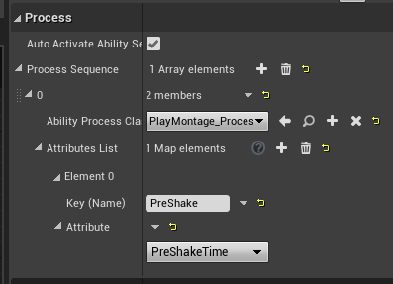

##### Ability Process Class:

Each AbilityProcess will only execute the next AbilityProcess if it returns successfully.

##### 2) Attributes List:

You can pass in the related attributes of AbilityProcess here. Of course, attributes can also be obtained in AbilityProcess by AbilityBlackBoard

#### 3.Effect List:

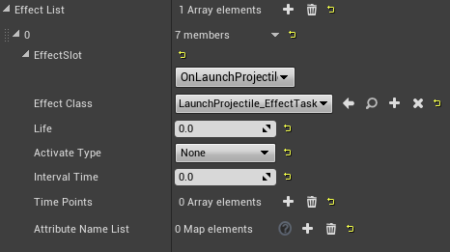

Note: When ActivateEffectTask () is executed, TaskBase will first look for the EffectTask that it has registered, then it will look for the parent TaskBase, and it will return until it finds it.

##### EffectSlot:

Will read the EffectSlot you set in AbilityBlackBoard, and you can select this EffectSlot by ActivateEffectTask() and execute it.

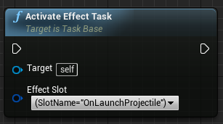

##### 2) EffectClass:

Select an Effect Task class

##### 3) Life:

Effect Task's life time, if 0, it will never be destroyed

##### 4) Activate Type:

None: Do not execute OnTimePointActivated () in any way;

IntervalTime: Execute OnTimePointActivated () at intervals;

TimePoints：OnTime Point Activated () will be executed at that time points.

##### 5) Interval Time

##### 6) Time Points

##### 7) Attribute Name List:

You can pass in the related attributes of AbilityProcess here. Of course, attributes can also be obtained in AbilityProcess by AbilityBlackBoard

### AbilityProcess:

Describe the specific process of the Ability and end the execution of FinishTask. You can use ActivateProcess () to manually execute an AbilityProcess.

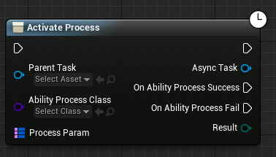

Override function:

|  |  |
| --- | --- |
| OnPreActivate | When AbilityProcess is pre activated |
| OnActivate | When AbilityProcess is activated |
| OnEnded | When AbilityProcess ends |
| OnInterrupt | When AbilityProcess is interrupted. |

Function:

|  |  |
| --- | --- |
| ActivateProcess | Manually execute an AbilityProcess. |
| FinishProcess | Ending an AbilityProcess. |

### EffectTak:

TaskBase other than detachment and Ability, will not be destroyed when the Ability are completed

Override function:

|  |  |
| --- | --- |
| OnPreActivate | When EffectTask is pre activated |
| OnActivate | When EffectTask is activated |
| OnEnded | When EffectTask ends |
| OnInterrupt | When EffectTask is interrupted. |
| OnTimePointActivate | When the point in time is activated. |

Function:

|  |  |
| --- | --- |
| EndEffectTask | Ending an EffectTask. |

## Make a Ability

### 1. Ability description:

### Fire a fireball and reach the target after 2 seconds, apply 50 damage every 0.5 seconds for 3 seconds

### 2. Basic Settings:

Check AbilitySystem in the plugin settings:

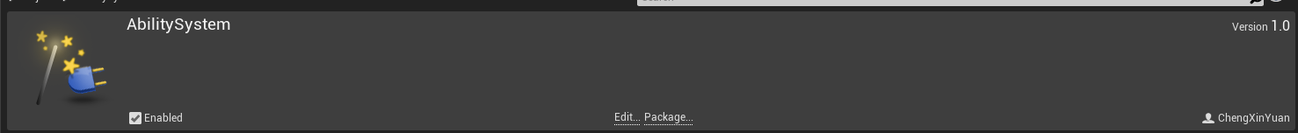

Right-click and select BlueprintClass to generate AbilityBlackBoard and name it BP_AbilityBlackBoard;

Right-click and select BlueprintClass to generate Ability and name it BP_Ability;

Right-click and select BlueprintClass to generate AbilityProcess and name it PlayMontage_Process;

Right-click and select BlueprintClass to generate EffectTask and name it LaunchProjectile_EffectTask;

Right-click and select BlueprintClass to generate EffectTask and name it Fire_EffectTask;

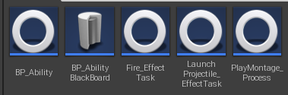

In Ability System Project Settings, set Ability BlackBoard Templete to

BP_AbilityBlackBoad:

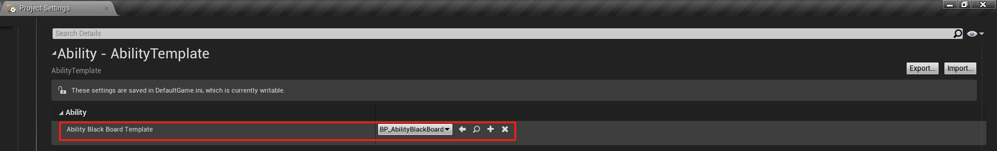

### 3. Setting Attribute and EffectSlot:

Open BP_AbilityBlackBoard and make the following settings

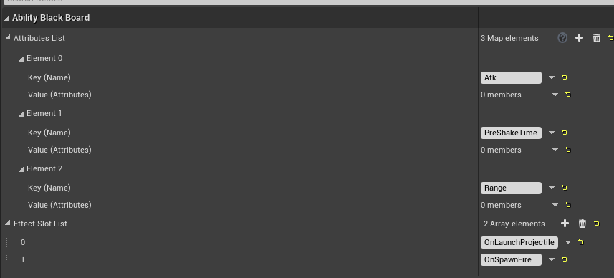

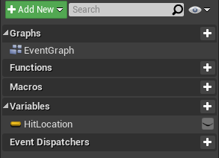

### 4.BP_Ability:

Open BP_Ability and make the following settings

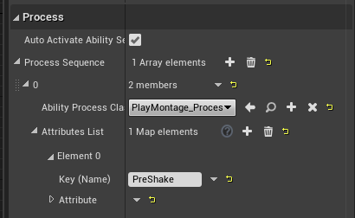

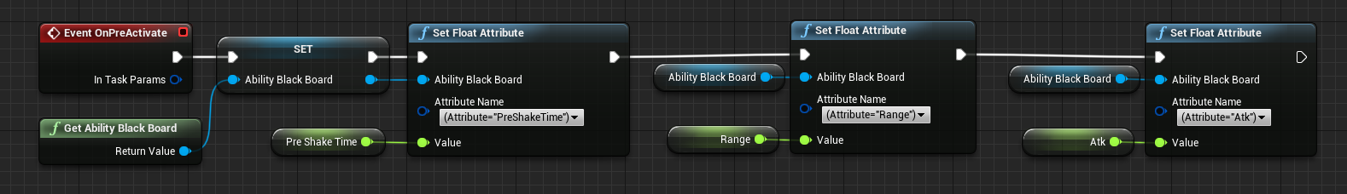

### 5.Edit PlayMontage_Process:

In the Play Montage Process, play the Montage of Ability, and pay attention to execute FinishTask () after

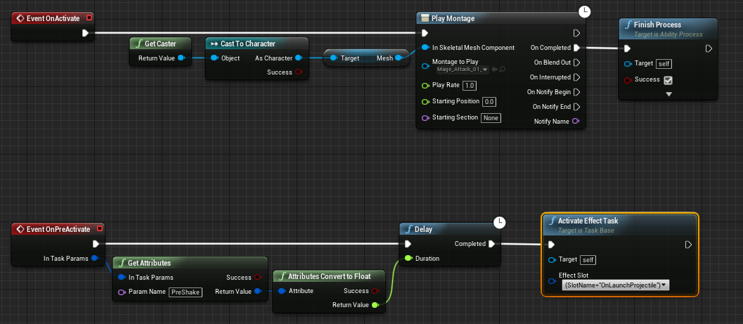

### 6. LaunchProjectile_EffectTask:

Release a fireball and produce a fire effect upon arrival (Fire_EffectTask)

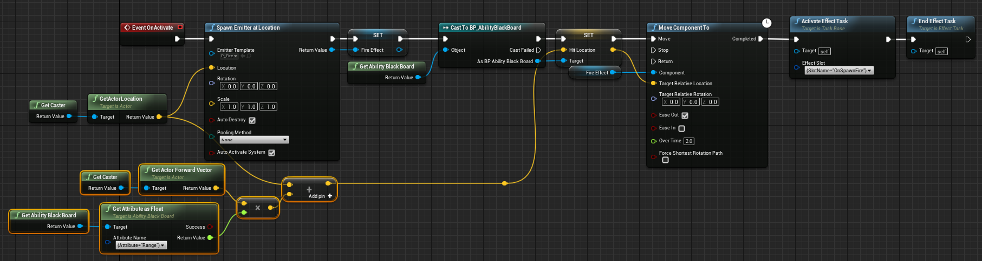

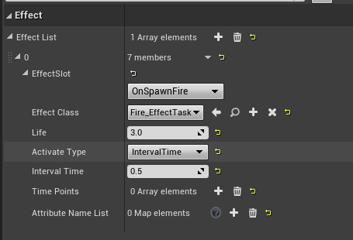

Remember to destroy the fire effects at the end of LaunchProjectile_EffectTask

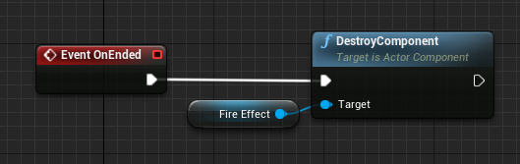

### 7. Fire_EffectTask：

Generates particle effects and deals damage each time it is activated

